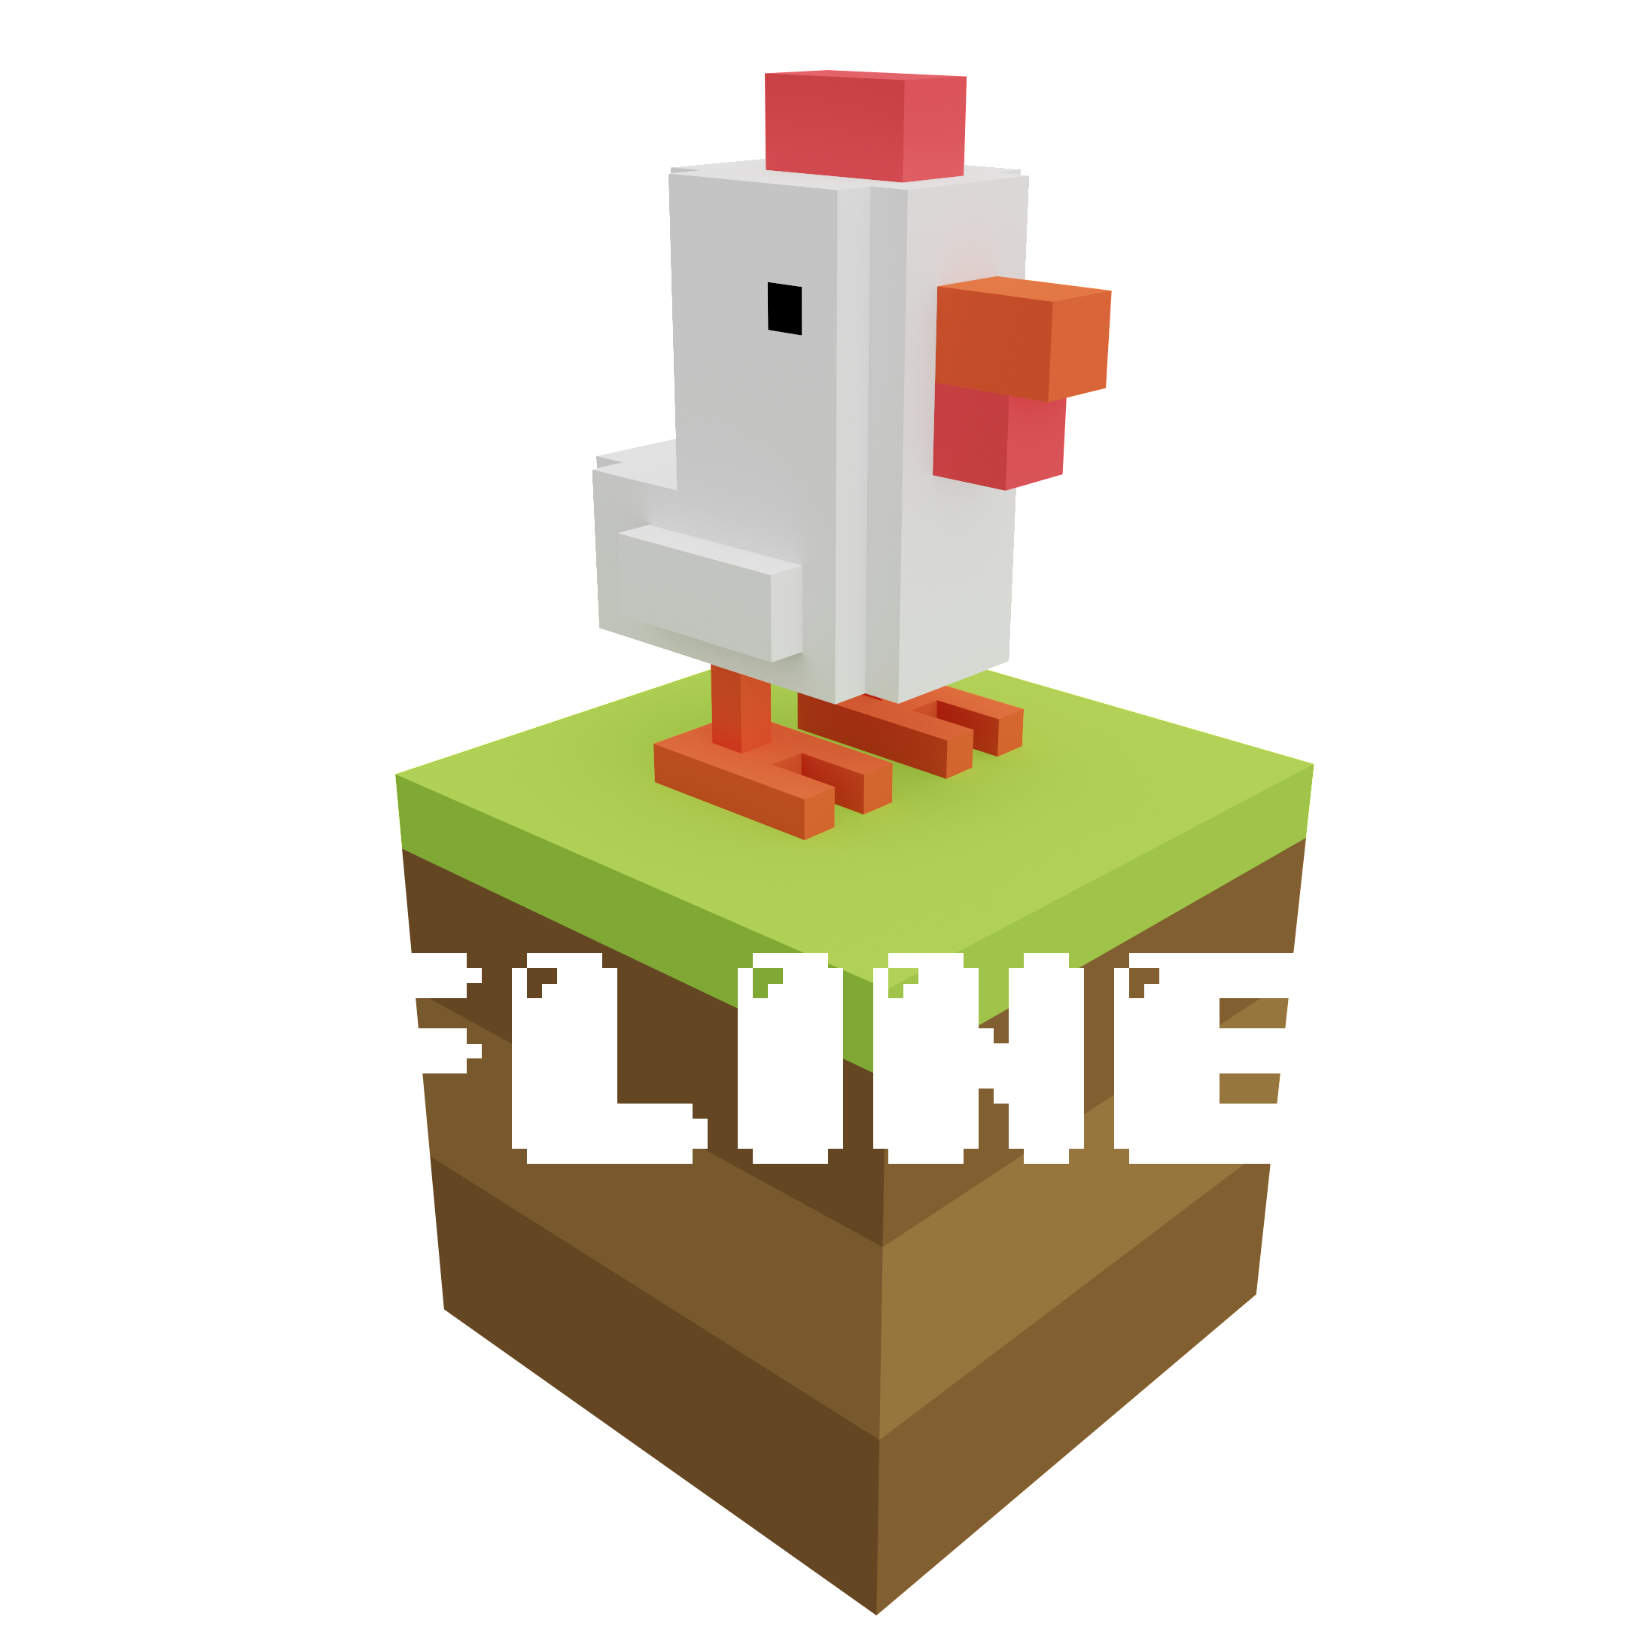

**GAME DESIGN DOCUMENT**

LAST UPDATED:

01/04/24

PREPARED BU:

SNAGBOX GAMES

**TABLE OF CONTENTS**

Short description 3

Gameplay 3

Overview of Gameplay 3

Description 3

Characters 3

Control 3

Level Design 4

Food 5

Losing 5

Art Style 6

Demographics 6

Platforms 6

Localization 6

# Short description

FLINE is a Sokoban-style game in which you control various characters in search of food by strategically pushing crates out of the way. Complete challenging levels filled with tricky obstacles.

# Gameplay

## Overview of Gameplay

Gameplay is similar to classic Sokoban game. The goal of the game is to get to all the food by building your own path.

## Description

FLINE is an addictive puzzle game that promises to bring you a lot of fun! In this game, the gameplay is inspired by the classic Sokoban, but with a fun and original approach.

Your goal is to get to all the food by making your own way through the maze of boxes. However, the path to food will be littered with obstacles, and only your dexterity and skill can help you overcome them.

Each level presents a new challenge that requires you to think strategically and plan. Use the boxes to create paths, open doors and avoid obstacles. But be careful - one wrong setting of the box can block your way!

In FLINE, you will find many levels of varying difficulty, great graphics and addictive gameplay. Immerse yourself in the world of adventure and accept the challenge of this exciting puzzle!

## Characters

1. Fline is the main character of the game. You can also buy various skins in the game.

## Control

Passing the levels requires high accuracy of controlling a character. To relieve the player, we abandoned many abilities, leaving only movements in different directions.

## Level Design

The level is a set of cubes through which you need to move. There will be a total of 30 levels divided into 2 difficulty groups.

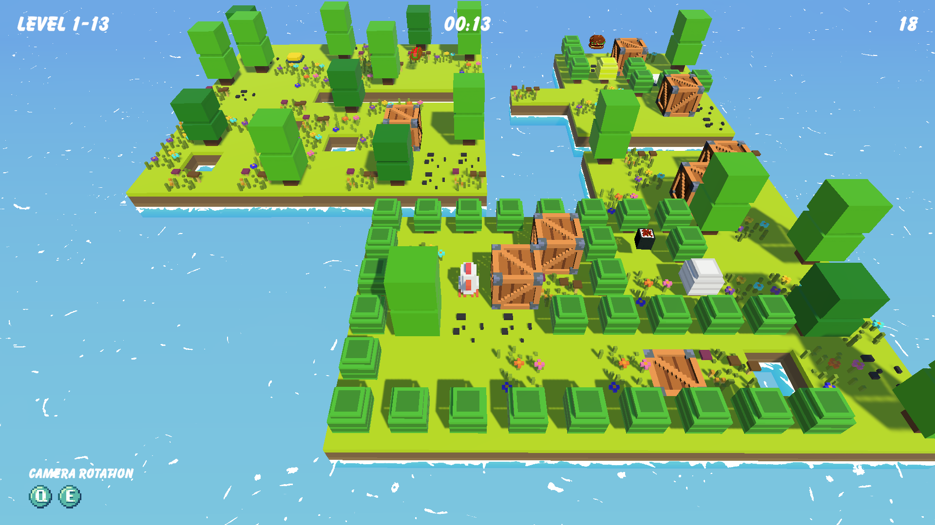

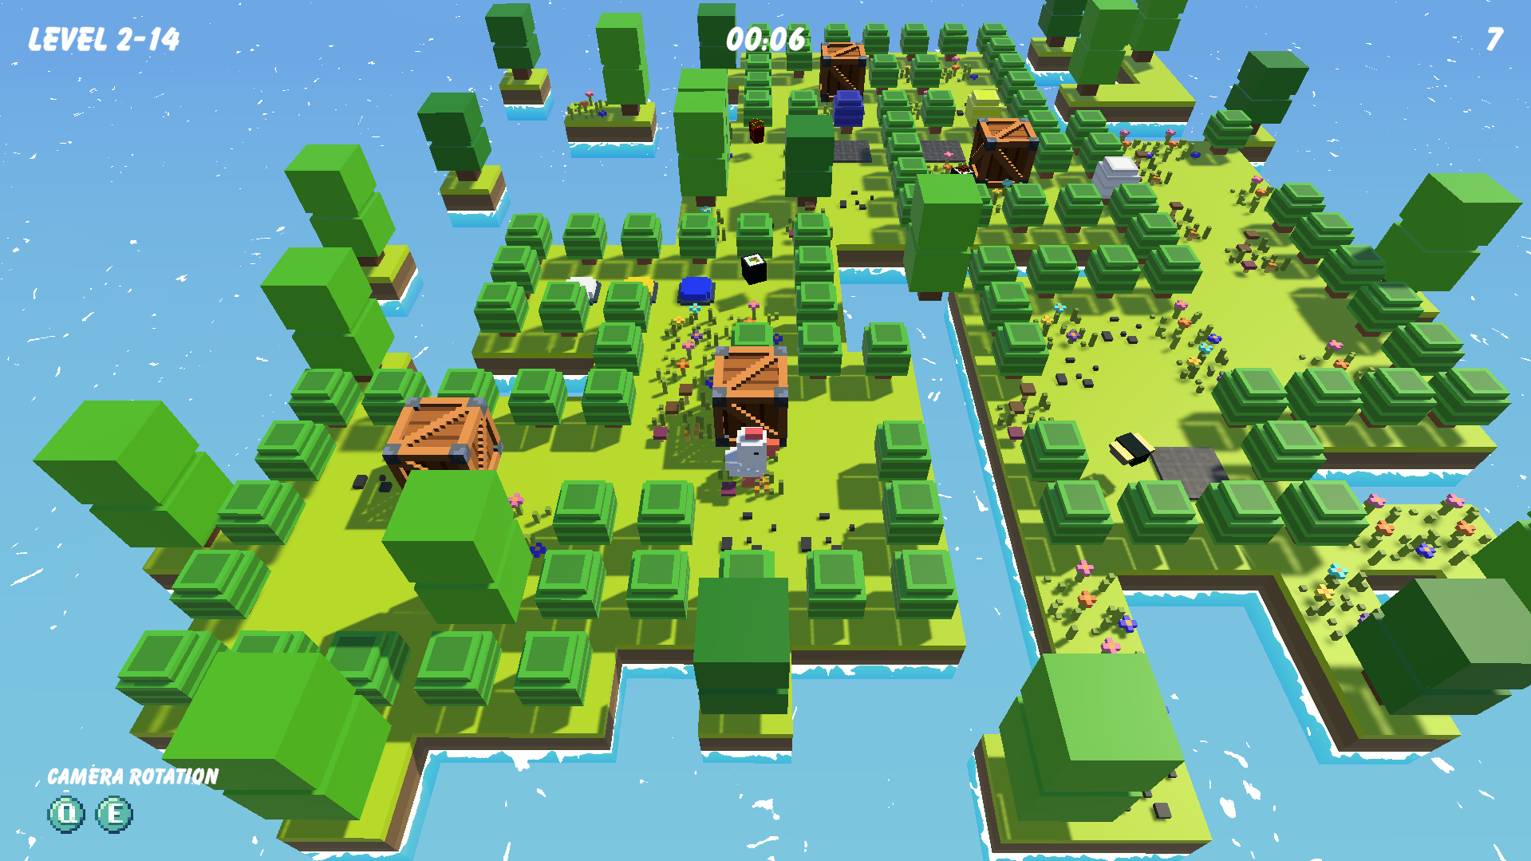

# Food

There is food scattered throughout each level. To complete the level, you need to collect food, and you can also buy various skins.

# Losing

The player only has one chance to complete each level. If the player places the box in the wrong place, he will need to restart the level and start all over again.

# Art Style

The game was made in a minimalist voxel style with the unique palette. We tried to use soft solid colors, so as not to burden a gamer.

# Demographics

The game intended for the audience of 6+.

# Platforms

Originally release of the game is planned for PlayStation platform. We also consider the release for Xbox, PC and Nintendo.

# Localization

At this stage, Russian, English, French, Japanese, German, Spanish, Portuguese and Chinese localization have been added.